OPEN DAY MINUTES
WP2/Task 5.7
April 22,2023

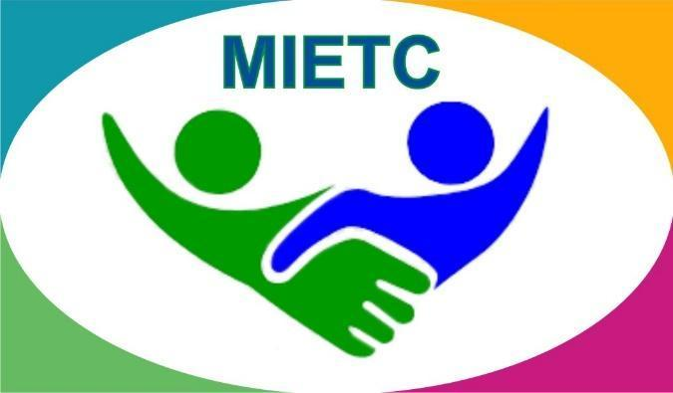

DEVELOPMENT OF A MASTER PROGRAMME IN THE MANAGEMENT OF INDUSTRIAL ENTREPRENEURSHIP FOR TRANSITION COUNTRIES
610198-EPP-1-2019-1-ES-EPPKA2-CBHE-JP

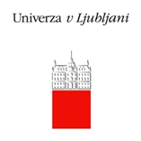
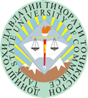

Table of Contents
Attendants.............................................................................................................................3
Minutes.................................................................................................................................6
WP 1. Description..................................................................................................................6
WP.2 Fotos........................................................................................................................ 6-8

Attendants

1 | Vadim Kim | Graduate student of the educational program "Economics"
2 | Alexandra Kobylskova | Graduate student of the educational program "Economics"
3 | Evgeny Konyukhov | Graduate student of the educational program "Economics"
4 | Ekaterina Lyubchenko | Graduate student of the educational program "Economics"
5 | Albert Metke | Graduate student of the educational program "Economics"
6 | Tomiris Akhmalisheva | Graduate student of the educational program "Economics"
7 | Nadezhda Zavadskaya | Graduate student of the educational program "Economics"
8 | Anna Mazyarkina | Graduate student of the educational program "Economics"
9 | Magomed Mezhidov | Graduate student of the educational program "Economics"
10 | Darina Otarova | Graduate student of the educational program "Economics"
11 | Alisher Seksembayev | Graduate student of the educational program "Economics"
12 | Nurlybek Kiyabek | Graduate student of the educational program "Economics"
13 | Nurtilek Zhunisbek | Graduate student of the educational program "Economics"
14 | Nurdana Bazarbekova | Graduate student of the educational program "Economics"
15 | Yelena Egorova | Graduate student of the educational program "Economics"
16 | Yegor Akulov | Graduate student of the educational program "State and local government"
17 | Assel Gabiden | Graduate student of the educational program "State and local government"
18 | Anel Kadyrmanova | Graduate student of the educational program "State and local government"
19 | Abuamir Zhumagulov | Graduate student of the educational program "State and local government"
20 | Maria Zevakhina | Graduate student of the educational program "State and local government"
21 | Yegor Parfenov | Graduate student of the educational program "State and local government"
22 | Dastan Ilyassov | Graduate student of the educational program "State and local government"
23 | Danil Nikolayev | Graduate student of the educational program "State and local government"
24 | Arailym Seypilova | Graduate student of the educational program "State and local government"
25 | Viktoria Strizhko | Graduate student of the educational program "State and local government"
26 | Alitair Tabaldayev | Graduate student of the educational program "State and local government"
27 | Aizada Abdrakhmanova | Graduate student of the educational program "State and local government"
28 | Tolganay Bolatova | Graduate student of the educational program "State and local government"
29 | Issa Abish | Graduate student of the educational program "State and local government"
30 | Kuanysh Ismagul | Graduate student of the educational program "State and local government"
31 | Nurtay Kaziev | Graduate student of the educational program "State and local government"
32 | Nurbek Kenzhebekov | Graduate student of the educational program "State and local government"
33 | Aygerim Kenzhebekova | Graduate student of the educational program "State and local government"
34 | Nurtilek Kurman | Graduate student of the educational program "State and local government"
35 | Zhanerke Zhenis | Graduate student of the educational program "State and local government"
36 | Kurmet Ermekuly | Graduate student of the educational program "State and local government"
37 | Zhanar Mustafina | Graduate student of the educational program "State and local government"
38 | Nigimet Zhalgas | Graduate student of the educational program "State and local government"
39 | Aida Aimaganbetova | Graduate student of the educational program " Project and innovation management"
40 | Aslan Bakhtiyarov | Graduate student of the educational program " Project and innovation management"
41 | Anastasia Dotsenko | Graduate student of the educational program " Project and innovation management"
42 | Anelya Zhansakalova | Graduate student of the educational program " Project and innovation management"
43 | Islam Rakhimgulov | Graduate student of the educational program " Project and innovation management"
44 | Aida Serik | Graduate student of the educational program " Project and innovation management"
45 | Malika Sarina | Graduate student of the educational program " Project and innovation management"
46 | Nursultan Fluk | Graduate student of the educational program " Project and innovation management"
47 | Diana Zhaksylykova | Graduate student of the educational program "International economy"
48 | Oral Zekenova | Graduate student of the educational program "International economy"
49 | Amina Baltabeva | Graduate student of the educational program "International economy"
50 | Kristina Bondar | Graduate student of the educational program "International economy"
51 | Alina Galiakhmetova | Graduate student of the educational program "International economy"
52 | Vladislav Kuleshov | Graduate student of the educational program "International economy"
53 | Nikita Shushunov | Graduate student of the educational program "International economy"

Minutes

On April 21, 2023, an Open Day was held at the Karaganda University of Kazpotrebsouz. The university was visited by graduating students and students from colleges and other universities. On this day, a unique opportunity was presented to get acquainted with the advantages of the university in order to make an important decision for yourself when choosing a university. At an interactive event right on the university square, everyone could demonstrate their abilities. In the hall of the Palace of Students, guests received a lot of positive emotions from an exciting concert program organized by students. At the exhibition and presentation of educational programs, applicants learned a lot of new and useful information about all the nuances of entering the educational program “Economics” and “Technological Entrepreneurship” at higher educational institutions.

Fotos

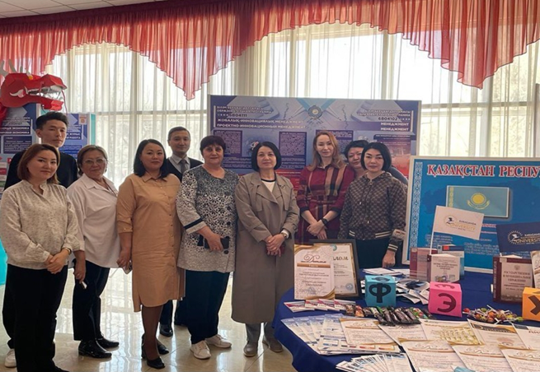
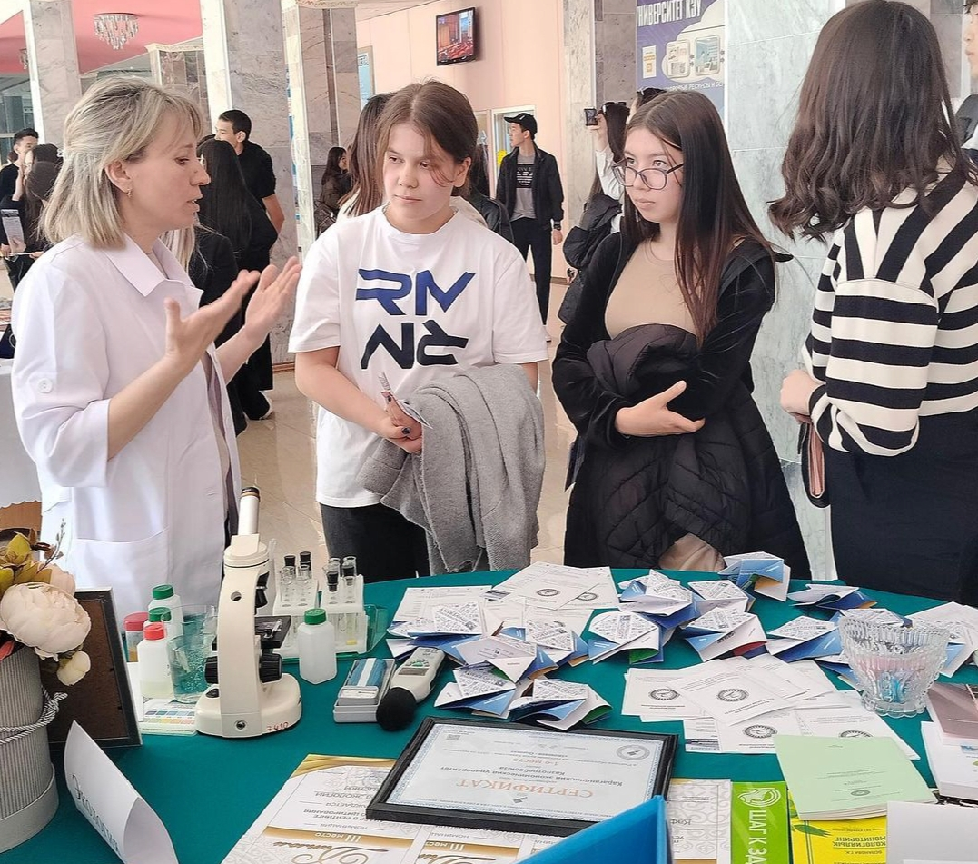3